User Guide
Starting The Program
To begin, run the program. You will be prompted to “Enter database name”. A valid database link should be typed in at this point followed by the enter key on your keyboard. Next, you will be prompted to “Enter username”. A valid username should be typed in now followed by the enter key on your keyboard. The final prompt will read “Enter password”. It is at this point where your user password should be typed in followed by the enter key. If you receive an error reading “No suitable driver found for [database you entered]”, the database name was entered incorrectly. If you receive an error reading “Access denied for user [username you entered]”, either the username or password was entered incorrectly. When all three prompts are answered correctly you will now see a message reading “Connection established”.

Traversing The Startup Menu
Next a menu with multiple options will appear allowing you to select one of the six presented. To select an option, you will be required to input a number ranging from 1-6.

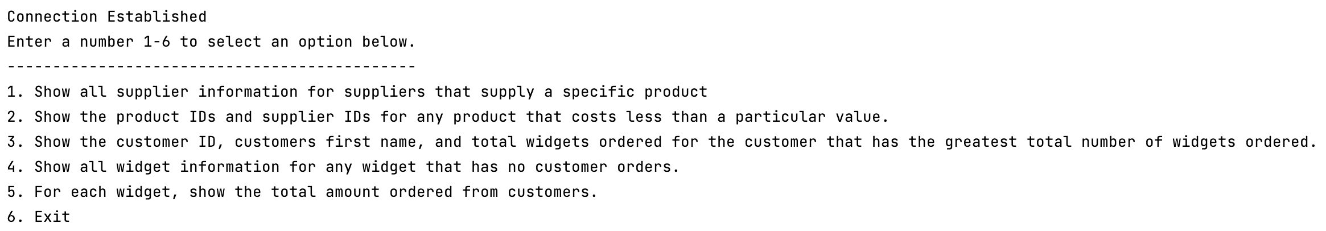
The function of these options will be explained in the next section of this guide.

Select the query you would like to run by entering the corresponding number followed by the enter key. Option six will exit the program.

Menu Options
Query 1:
The purpose of this query is to show supplier information for every supplier that supplies a particular product. After selecting this query, a prompt will appear asking for a product number. You may enter a valid product number by entering the single product id of your choice followed by the enter key.
Results for a valid product id will be as follows: The unique supplier identification number of a supplier that supplies this product. The street where that supplier is located, the city where that supplier is located, the state where that supplier is located, and finally the zip code where that supplier is located. Each row in the table pertains to one supplier.

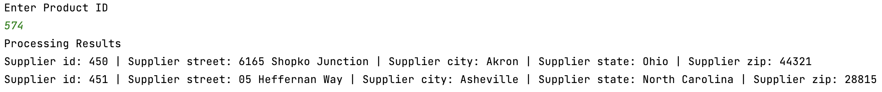
Example of the query with a valid product id.

After the results are displayed you will be taken back to the startup menu where you can run a query again or exit the program as directed.
If a non-numerical value is submitted, you will be prompted with a message reading, “Please enter a number”. If a numerical value not corresponding with a product identification number is submitted, you will receive no information and be redirected to the startup menu.
Query 2:
The purpose of this query is to show the product identification numbers and supplier identification number for any products that cost less than a particular value. After selecting this query, a prompt will appear asking to “Enter Product Price”. You may enter a valid product price by typing in either a whole number or a number with to decimal places after. The resulting information will be grouped by the product identification numbers.
Results for a valid product price will be as follows. The product identification number for a product that costs less than the entered value, and the supplier identification number that supplies that product. Each row in the table pertains to one product.

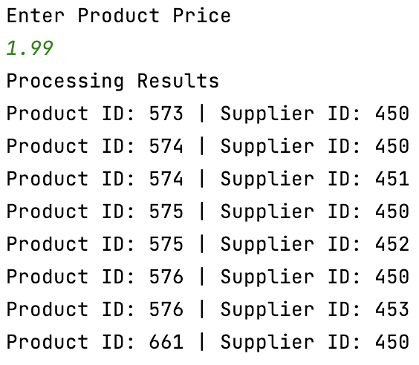
Example of the query with a valid price.

After the results are displayed you will be taken back to the startup menu where you can run a query again or exit the program as directed.
If a non-numerical value is submitted, you will be prompted with a message reading, “Please enter a number”.
Query 3:
The purpose of this query is to display the customer identification number, customer first name, and the total widgets ordered from the customer who has order the greatest number of widgets. After selecting this query no additional input will be required. The resulting information will be grouped by customer identification number as follows.
The customer identification number and first name from a customer who has ordered the highest total number of widgets, followed by the actual order quantity from that customer. It is possible to have multiple customers displayed if there is a tie in the order quantity.

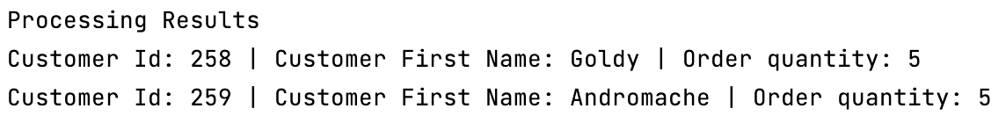
Example of the query.

After the results are displayed you will be taken back to the startup menu where you can run a query again or exit the program as directed.
If there are no widget orders, then you will receive no customer information and be taken to the startup menu again.

Query 4:
The purpose of this query is to show the widget information for any widget that has not been ordered by customers. After selecting this query no additional input will be required. The resulting information will be grouped by widget identification number as follows.
The widget identification number, widget weight, widget name, and widget cost from the widget or widgets that have not been ordered by customers. There can be a single line or multiple lines of information depending on your data.

Example of the query.

After the results are displayed you will be taken back to the startup menu where you can run a query again or exit the program as directed.
If there are no widgets that have zero customer orders, then you will receive no information and be taken to the startup menu again.

Query 5:
The purpose of this query is to show the total amount of customer orders for each widget. After selecting this query no additional input will be required. The resulting information will be grouped by widget identification number as follows.
The widget identification number followed by the total amount ordered from customers for that widget.

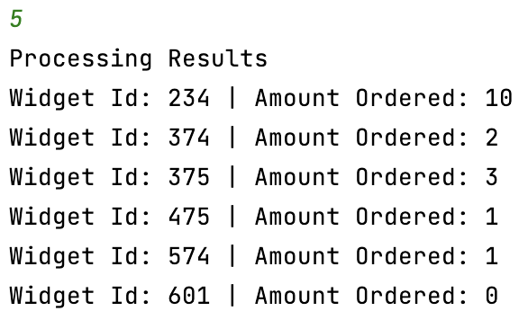
Example of the query.

After the results are displayed you will be taken back to the startup menu where you can run a query again or exit the program as directed.
The only way you will receive no information is if there are no widgets in the system since this query will show even widgets with 0 customer orders. If no information is provided, then you will be taken to the startup menu again.

